28th April 2014

Dear Colleague,
Following our letter in January we would like to take this opportunity to update you on progress regarding club swimming and the performance pathway in Birmingham.
A meeting took place on Friday 11th April between the ASA and Birmingham City Council and the following was agreed:
- A further meeting will take place in May with the University of Birmingham to continue to explore our partnership for competitive swimming.
- A meeting with take place in May between BCC and the ASA to support the writing of contract specifications for the tender documents.
- Competitions between potential bidders will commence in June, with final tender submissions expected in December, for contracts to begin in April 2015.
To reiterate, this is a very positive working relationship and an excellent opportunity to ensure the needs of the swimming clubs in Birmingham are represented. Birmingham City Council remains very committed to performance swimming. The desired outcome of these discussions is that we have a sustainable swimming model in Birmingham that supports the swimmer pathway to give everyone the opportunity to achieve their potential.
We will write to you again, following our meetings in May, to update you further.

Kind Regards
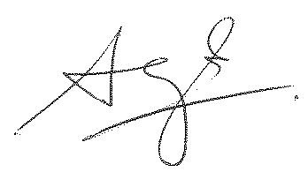

Lesley Hill Steve Hollingworth:
ASA Birmingham City Council

